

**KD6040**

**Individual Physics Project**

**PROJECT PLANNING DOCUMENT**

**BSc (Hons) Physics with Astrophysics**

**2019/2020**

**The Formation and evolution of Blue supergiant stars**

Thomas Scattergood

w17009197

Natasha Jeffrey

Date of Submission

**Declaration**

I hereby declare that the work contained in this document is all my own work. I also confirm that when this work uses ideas and opinions from the work of others, these are credited in full by citing the corresponding references.

Name: Thomas Scattergood

Signature: T.Scattergood

Date: 27/10/2020

# INTRODUCTION

Blue supergiants (BSG) are stars that form in dense, cold and large molecular clouds known as nebula and have huge masses, luminosities and temperatures when compared to stars like our sun. Our sun began forming in a nebula when a dust cloud collapsed[1] and formed a solar nebula, which has enough angular momentum to cause a spinning effect on the cloud. Over a large amount of time, gravity caused enough pressure for the hydrogen atoms to fuse into helium with the release of tremendous amounts of energy, which acted as a kick-start for the sun [1].

BSG are found near the top left of the Hertzsprung-Russell diagram which is a diagram that can be useful to differentiate stars into their respective spectral classes which are determined by their temperature and their spectral features [2]. Figure 1 shows an example of the Hertsprung-Russell diagram that also shows the spectral classes and luminosity classes. BSG are generally found on the far most left part of the x-axis of temperature and at the top of the y-axis of luminosity.

Blue supergiants are classified as either O type or B type stars based on their surface temperature of at least 11,000K and blue supergiants are classed often as Ia luminosity class for the particularly bright stars and Ib for the less luminous supergiants. O and B type stars account for some of the hottest and brightest stars in the universe. The sun is classed as a G type star due to its surface temperature of around 6000K and has a luminosity class of V for it being a yellow dwarf star, which is a common type of main sequence star [2].

BSGs are much larger than both our sun and solar-like stars with some of the smallest having a solar radius of 14 R­ʘ (14 times the radius of our sun). Most BSG have a solar mass of at least 10Mʘ (10 times heavier than our sun) and the dimmest have luminosities of around 20,000 Lʘ (20,000 times more bright than the sun [21]. This scale of luminosity leads to BSG being relatively easy to spot in the night sky[2]. Yet, compared to other star types, such as yellow dwarfs there seems to be a very small number of them.

A comparable feature of BSG to solar like stars are solar/stellar flares which magneto hydrodynamics (MHD) can help us study. Stellar flares have huge releases of energy and lead to a temporary increased brightness of the star. They are sometimes accompanied by a coronal mass ejection (CME) which is the ejection of plasma from the solar corona; the CME can collide with the Earth’s magnetic field and cause the aurora borealis and aurora australis (the northen and southern lights) [3].

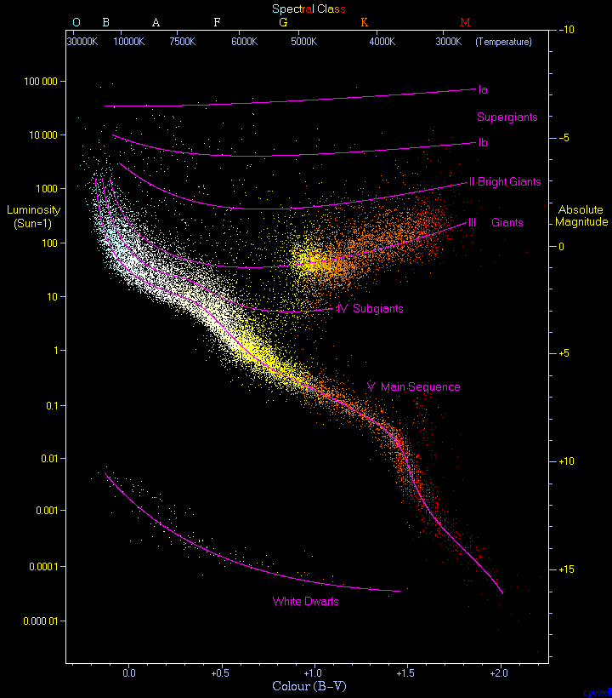

Figure 1: The Hertzsprung-Russell diagram shows the classification of different star types based on luminosity and surface temperature [4]. BSG are located around the top left of the diagram whereas the sun is located around the center of this diagram.

In fact BSG account for less than 1% of all stars in the known universe[3][5], this could be due to their main sequence phase being much shorter than most other star types with the average main sequence phase lasting only around 10 Myr. For comparison our sun will spend around 10 billion (103 Myr) in its main sequence phase. “The length of the main sequence phase is governed by the nuclear time scale, with more massive stars having shorter main sequence life times” [6]. When formed BSG are huge so therefore require a large amount of fuel for nuclear fusion to occur in the solar core; this happens at a much faster rate than in smaller stars leading to the short-lived main sequence phase. The bigger the star, the faster the fuel is consumed and therefore the shorter the main sequence phase.

BSG have a huge output of radiation that originates in the solar interior, which also causes huge amounts of radiation pressure within the star. This is potentially created during the nuclear fusion process via the CNO cycle [7] The CNO cycle is a nuclear fusion process that involves the use of Carbon, Nitrogen and Oxygen to burn hydrogen and create Helium with a release of energy. It is the nuclear fusion process found in giant stars and it differs to nuclear fusion processes in the sun and smaller types of stars such as G type-stars. This is because the sun uses a nuclear fusion process called proton proton fusion which involves hydrogen fusing together to create helium with a release of energy. This process involves no interaction with carbon, nitrogen or oxygen. Figure 2 shows the full process of the CNO cycle. These huge amounts of radiation pressure produce another phenomenon often seen in O and B type stars known as stellar winds [8], which is described as the continuous flow of material[4] out of the star.

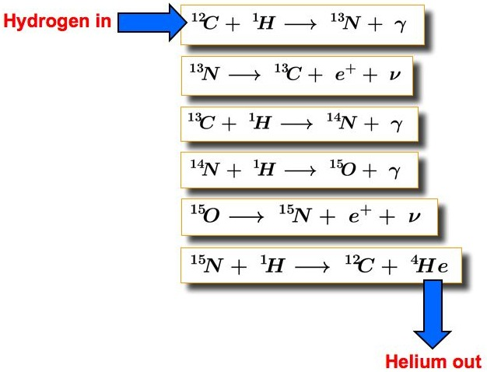

Figure 2: The CNO cycle produces He from C, N and O interacting with H atom, it is the nuclear fusion process in huge stars such as Blue supergiants [7]

The stellar winds of BSG can be observed via a characteristic spectral line shape (the P Cygni profile) of BSG which can either be blue shifted which is observed when the stellar winds move towards us as observers or have red emissions from the stellar winds scattering light particles/the stellar wind emitting light particles. Therefore, it is possible to see that stellar winds play an important role in O and B type stars including BSG. BSG also experience major mass loss of around 10-9-10-5 Mʘ yr-1 [9], which can change factors that rely on the mass of a star. Mass loss could potentially influence the length of the main sequence of BSG due to the length being governed by the nuclear time scale and the nuclear timescale changes with mass [6].

The evolution of blue supergiants plays an impactful role despite an accountability of small proportions due to their highly destructive death. “The formation, evolution and explosive deaths of massive stars impact the surrounding interstellar medium and shape the evolution of their host galaxies” [6]. When a blue supergiant evolves past its main phase it mainly takes one of two paths; both paths start with a supernova and then the mass of the core determines the next step in the evolutionary path. If there is more than 3Mʘ in the core after a supernova then the star will collapse into a black hole. If there is less than 3Mʘ then instead a neutron star forms which contains around 2Mʘ in a star that has a radius of around 10Km. It is clear to see that having that much mass in such a small object results in a tremendously dense celestial body [10]

Both of these evolutionary paths can be very destructive and have huge impacts on the surrounding environment. Supernovas are huge star explosions that occur when the nuclear fusion process runs out of fuel to burn in the solar core, which causes mass to enter the core until it collapses under its own gravitational force. Once the core collapses, the star explodes sending star material, elements and space debris at large speeds throughout its local galaxy, which in time will affect the evolution of galaxies, stars and the interstellar medium in general [11]. The other main evolutionary path that BSG can take once they die are black holes, which have incredibly strong gravitational fields that not even light can escape. There are two types of black holes, stellar mass and supermassive. Supermassive black holes have a mass of around 1,000,000Mʘ and are found at the center of every large galaxy. Stellar mass black holes are the more common type and have mass up to 20Mʘ and is the type most associated with BSG. This type of black hole forms when a supernova occurs and if the core contains more than 3Mʘ [12].

Once passed the main sequence phase, and the nuclear fusion process runs out of fuel the BSG will go supernova and then the next stage depends on the mass in the core, if the mass exceeds a certain limit then it will turn into a black hole, if the mass is not large enough then a neutron star will form after the supernova.

Blue supergiants having a much shorter main sequence gives a challenge of a shorter time frame to study specific phases of its life but could potentially allow the study and further the understanding of solar interior and stellar evolution.

# 2. AIMS AND OBJECTIVES

The main aim of this project is to research and understand the fundamental formation of blue supergiant stars and how these stars evolve into, through and past their main sequence phase into more impactful celestial phenomena known as supernovas and black holes. The objectives to achieve this aim are:

1. To study and analyse the conditions that lead to the formation of a blue supergiant star by examining the pre nebula of existing blue supergiant stars
2. To investigate the potential evolutionary path and how the death of a blue supergiant star can affect the surrounding universe either by a supernova, black hole or other factors
3. To compare the stellar composition, structure, magnetism (and features such as stellar flares and starspots) and processes such as nuclear fusion of blue supergiant stars to solar-like stars

# 3. THEORY/METHODOLOGY

**3.1 Summary of theory**

BSG are classed as O and B type (sometimes known as early type) stars that are much bigger, hotter and luminous than stars of a lower class such as G or K type. They are very rare in terms of numbers but are still easy to find due to their vivid brightness in the night sky. They experience much shorter main sequence phases because they burn a lot more hydrogen to maintain the nuclear fusion process

The nuclear fusion process that occurs in BSG is the CNO cycle that instead of fusing hydrogen into helium like most solar like stars, undergoes several reactions involving hydrogen, carbon, nitrogen and oxygen to produce helium. The presence of heavier elements in this process results in BSG being important metal producing factories in the universe and once it evolves past its final stage this material could be sent out into space and end up elsewhere.

BSG experience huge amounts of radiative pressure in the solar core which leads to a characteristic stellar winds which ejects material out of the star. Over a period of time this leads to a significant amount of mass to be lost from the star by the standards of the mass of the sun, however a small amount of mass when compared to the BSG undergoing the mass loss[5].

* 1. **Theory to be used**

Research has found that the processs of giant star formation is vaguely similar to solar like stars in the sense that they form in dense, compact clumps in molecular nebula, the main difference in the starting steps of formation is the hydrogen density within the nebula region. Regions that will form a giant star have densities around 1023- 1024 H atoms cm-2 whereas smaller star producing nebula will have a lower density of hydrogen. These regions have been found to have gas temperatures of T= 10-20K, and masses of M=100s-1000s Mʘ [13]. The values of both of these parameters are much higher than the values found in nebula that make solar-like and smaller stars. Supersonic turbulence, in the form of “shock compression from convergent turbulent gas streams” plays a key part in the next step of massive star formation. Depending on the direction of the turbulence with respect to the magnetic field lines, the magnetic field will either undergo flux freezing and be boosted or will quickly collapse [13]. If the former occurs then the clump will be stabilized by magnetic forces against the gravitational forces, this is known as subcritical compression. If the latter occurs then as stated before the clump will quickly collapse, this is known as supercritical compression. Subcritical compression makes it so that collapse takes a long time which could result in subfragmentation. “Only supercritical compression leads to massive star formation” [13].

Wolf-Rayet (WR) stars are a specific type of early type star in which they are late main sequence phase supergiants that have huge effective temperatures from 10000K-30000K, have solar masses of 50Mʘ and will evolve past its main sequence phase in a short period of time. They have strong characteristic stellar winds (could lead to large mass loss) and they are most likely to undergo a core collapse supernova. [14].

O type, B type and evolved WR stars have a characteristic spectral line shape known as a P Cygni profile which is a combination of features in a star’s spectrum observed in the ultraviolet spectra, it has two main characteristics [15]:

1. Blue shifted absorption dip: Caused by absorption of the star’s radiation by the stellar wind moving towards us, between us and the star
2. Red wing emissions: Caused by light scattered towards us by light particles in the wind and light that is directly emitted by the stellar wind

A P Cygni profile is caused by a star experiencing stellar winds and experiences absorption and emissions which is characterized and described in figure 3 below.

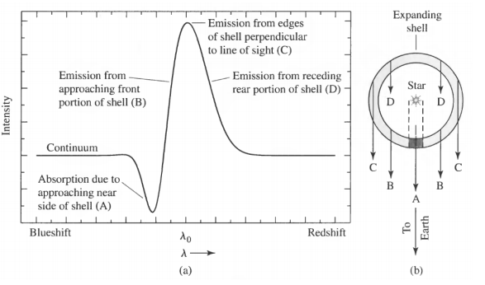

Figure 3: (a) A general explanation of a P cygni profile with a broad emission line peak and an absorption trough. (b) Demonstration of an expanding mass shell of a star, the posititions of the letters indicate which part of the emission comes from which part of the expanding shell [16]

BSG experiencing mass loss in which stellar winds eject material out of the star over time can lead to a significant amount of mass being lost. Mass loss of O-type and B-type supergiants can be estimated using the following formula [18]:

$$\log\left(\frac{dM}{dt}ν_{∞}\sqrt{R_{*}}\right)= -10.47+1.557* log⁡(L_{*})$$

Where: dM/dt= Mass loss [Mʘ yr-1]

= Stellar wind velocity [km s-1]

R* = Radius of the star [Rʘ]

L* = Luminosity of the star [Lʘ]

Using this equation to calculate mass loss can be useful because as shown many things can be shown to be a function of mass (such as the nuclear time scale and therefore the length of the main sequence phase). Also it can be shown that mass loss relies on the velocity of the stellar wind, with higher stellar winds ejecting material faster resulting in more mass loss. This method will be used to analyze the impact that mass loss and stellar winds have on the main sequence phase of BSGs.

The nuclear time scale is defined as the time that a star can continue to radiate a specific nuclear fusion process and is given by the formula [19]:

$$t_{nu}={1x10}^{10}\left(\frac{M}{M_{ʘ}}\right)(\frac{L}{L_{ʘ}})^{-1} [yr]$$

It is clear to see that tnu is a function of mass and therefore will change as mass changes.

The nuclear fusion process in the solar core of O and B-type stars is the CNO cycle which was briefly described, shown and compared to the nuclear fusion process in solar-like stars. Figure 2 shows the full cycle starting 12C absorbing a H atom, to the final step of 15N absorbing a H atom and turning into 12C and 44He atoms, the 12C then repeats the process granted there’s H to absorb. One full period of the CNO cycle releases around 24.7MeV. Whereas the main proton-proton fusion reaction (P-P chain reaction 1) in the sun is around 26.7MeV [20].

Many stars experience starspots and stellar flares, the sun experiences flares that last between 100s-1000s s. BSG may experience stellar flares that last longer, are hotter, bigger and have more energy due to a potential correlation between stronger gravity and more intense stellar flares [3]. Sunspots/starspots are defined as regions on a star’s surface with intense magnetic fields (B fields) that form as a result of magnetic flux emergence in the solar interior, the sun has sunspots that take 3-10 days to form and have maximum B field strengths of around 3KG (kiloGauss) which equates to 0.3T (Tesla), this stays constant as the sunspot decays and the area decreases. Recent research in magnetohydrodynamics suggest that some BSG have strong, stable magnetic fields with strengths that can range from 100s of Gauss to a few kiloGauss. Comparing this to the B field strength at the polar surface of the sun, which on average is around 10 Gauss, shows that it is possible for a small amount of O and B-type stars to experience magnetic phenomena such as starspots. The increased B field strength could lead to longer, bigger starspots with more intense B field regions [21].

When it comes to the final evoluionary stages of an early type star, the aforementioned stages occur with all of them having differing levels and types of impact on the interstellar medium. Firstly supernovas cause shockwaves through the local interstellar medium along with large doses of energy that can reshape interstellar material and effect nearby stars and local clusters [22]. On the other hand black holes are quite destructive in nature due to the inescapable gravitational force pulling even light into it. Nearby celestial objects will be pulled into the black hole. Anything that moves past the black holes event horizon will also be dragged in. It is near impossible to determine the true scale of effects that both of these evolutionary paths have on the interstellar medium and the local medium around them. Supernova’s could be seen as constructive as well as destructive due to the injections of energy assisting in the formation and evolution of distant galaxies and solar systems. A possible analysis of regions of interstellar space that have been exposed to a recent supernova could assist in researching the impact it has.

# WORKPLAN

**4.1 Preliminary Work**

For background research, I started off by studying the classification of stars and their spectral types to get an understanding of the type of data I would need to specify when looking for examples. I discovered that supergiants occupy the spectral class of O and B type stars which are characterized by a minimum surface temperature of 11,000K. I then looked at the Yerkes luminosity table [2] that categorizes all-stars based on the width of their spectral lines with the further up the table you go, the brighter and bigger the stars get. Blue supergiant stars have a luminosity class of I[6], which is often split into Ia being the very luminous supergiants and Ib being the less luminous supergiants [2].

I then looked at the basic properties of BSG such as mass, temperature, luminosity and radius as well as finding examples of BSG using a star database [23]. For example, I used this database to find out the properties of Rigel in the Orion constellation and found the accurate data that was required along with data for many other BSG from the same database [24]. The properties found include its mass of around 21 Mʘ, luminosity of 120,000Lʘ, temperature of 12,100K, age of around 8Myr and radius of 78.9Rʘ.

I then turned my attention to the main sequence phase and the several factors that determine this part of the stars evolutionary path. I looked at the nuclear time scale, which determines how long a star, will live in its main sequence phase and how this can change with mass or luminosity. I also looked at the CNO cycle [25], which allows nuclear fusion to occur in the core of BSG. I briefly looked at stellar winds that push material out of the star, which led to me then researching mass loss of giant stars.

Finally, I researched the final stage in the evolutionary path of BSG and the basic definitions of what those paths are and differentiated the difference between the two paths.

Not much research has been found on the pre nebulas of BSG at the time of writing this document so this research will be completed at a later stage, in the meantime I will be exploring the fundamental properties of nebula and star formation to get an understanding of star formation so I can more efficiently understand the formation of BSG.

* 1. **Milestones and next steps**

To achieve objective one I will need to find information about the nebula of BSG, how these stars form and general star formation from a gas nebula, so my milestones for objective one will be:

Milestone 1: Explore the properties of giant star producing nebula

Milestone 2: Explore how gas collapse leads to the formation of a star

For objective two I have already mentioned and discussed evolutionary paths of BSG so I will need to go into more detail about the differences between these paths and the influence of both paths of the interstellar medium. I will also look at mass loss in more detail to determine if it has a substantial impact on the main sequence and evolution of BSG. Therefore, my milestones for objective two will be:

Milestone 3: Compare black holes and supernovas in terms of forces and affect on the interstellar medium including planets and space debris.

Milestone 4: Explore mass loss and determine how much of an affect it has on the main sequence phase and lifetime and evolutionary path of BSG?

For objective three I will look at stellar features of BSG such as sunspots and stellar flares and how these can be comparable in size, energy, timescale, etc. to solar like stars. I will also describe the CNO process in detail and calculate an estimation of the energy it releases. Therefore my milestones of objective three are:

Milestone 5: Determine if O-type and B-type stars experience stellar flares/starspots and if so compare properties to solar-like stars

Milestone 6: Research in detail the CNO cycle and how this fusion process differs from nuclear fusion in solar like stars (energy difference, different reactions, etc.)



Figure : A Gantt chart to show an estimate of time scale for the project

# 5. REFERENCES

1. NASA Solar System Exploration. 2019. Our Solar System.
2. Enchantedlearning.com. 2018. Star Classification - Zoom Astronomy. {Accessed 10 November 2020]
3. Balona, L., 2015. Flare stars across the H–R diagram. *Monthly Notices of the Royal Astronomical Society*, [online] 447(3), pp. 9. [Accessed 10 November 2020].
4. Kaler, J., 2006. *The Cambridge Encyclopedia Of Stars*. 1st ed. Cambridge: Cambridge University Press, pp.99-102. [Accessed 18 November]
5. n.d. Massive Stars. 1st ed. [ebook] Paris: Institut d'Astrophysique de paris, pp.1-5. {Accessed 28 October 2020]
6. Bowman, D.-M., Asteroseismology of High-Mass stars (2020) [Accessed 4 November 2020]
7. Astronomy.swin.edu.au. n.d. CNO Cycle | COSMOS. [Accessed 4 November 2020]
8. Astronomy.swin.edu.au. n.d. *Stellar Winds | COSMOS*. [Accessed 2 November 2020]
9. Martins, F. et al. 2015. *Mass Loss Of Massive Stars*. 1st ed. [ebook] https://www.agnesscott.edu/, pp.1-2. Available at: <https://www.agnesscott.edu/sciencecenterforwomen/research/ssp/files/documents/gordon-ref2-massivestars.pdf> [Accessed 10 November 2020]
10. Naeye, R., 2008. *NASA - Neutron Stars*. [online] Nasa.gov. Available at: <https://www.nasa.gov/mission_pages/GLAST/science/neutron_stars.html> [Accessed 10 November 2020].
11. May, S., 2013. What Is A Supernova? NASA [Accessed 4 November 2020]
12. Wild, F., 2018. What Is A Black Hole? NASA [Accessed 4 November 2020]
13. Zinnecker, H. and Yorke, H., 2007. Toward Understanding Massive Star Formation. *Annual Review of Astronomy and Astrophysics*, 45(1), pp.11-15. [Accessed 13 November 2020]
14. Gómez-González, V.,et al, 2020. Wolf–Rayet stars in the Antennae unveiled by MUSE. *Monthly Notices of the Royal Astronomical Society*, 1(1), pp.1-2. [Accessed 6 November 2020]
15. Ostlie, D. and Carroll, B., 2007. *An Introduction To Modern Stellar Astrophysics*. 1st ed. San Francisco: Pearson Addison-Wesley, p.470. [Accessed 12 November 2020]
16. Kasai, Eli. (2013). THE TYPE IA SUPERNOVA RATE IN INTERMEDIATE REDSHIFT GALAXY CLUSTERS. 10.13140/RG.2.1.2808.8803, pp. 27 [Accessed 13 November 2020]
17. Castor, J. and Lamers, H., 1979. An atlas of theoretical P Cygni profiles. *The Astrophysical Journal Supplement Series*, 39, p.481. [Accessed 12 November 2020]
18. Lamers, H., 1996. Mass Loss from Stars. *From Stars to Galaxies: The Impact of Stellar Physics on Galaxy Evolution*, 98, pp.171-172. [Accessed 12 November 2020]
19. Wicks, R., 2020. *The Sun's Interior*. Pp 4 [Accessed 17 November 2020]
20. Zoppi, G., 2019. Thermal and nuclear energy. pp 64 [Accessed 17 November 2020]
21. Grunhut, J., n.d. *Magnetic Fields In Early-Type Stars*. [Accessed 14 November 2020]
22. Frisch, P. and V. Dwarkadas, V., 2018. Effect of Supernovae on the Local Interstellar Material. *Cornell University*, pp.3-8. [arXiv:1801.06223](https://arxiv.org/abs/1801.06223) [Accessed 13 November]
23. Star-facts.com. 2020. *Facts: Size, Mass, Luminosity, Name, Constellation | Star Facts*. [Accessed 17 November 2020]
24. Star-facts.com. 2019. *Rigel (Beta Orionis) Facts: Size, Mass, Luminosity, Name, Constellation | Star Facts*. [Accessed 10 November 2020]
25. Millis, J., 2020. *Blue Supergiants Live Fast, Die Quickly, And Leave A Beautiful Nebula*. [online] ThoughtCo. [Accessed 30 October 2020]
26. Georgy, C.; Saio, H.; Meynet, G. (2013). "The puzzle of the CNO abundances of α Cygni variables resolved by the Ledoux criterion". *Monthly Notices of the Royal Astronomical Society: Letters*. **439**: L6–L10. [arXiv](https://en.wikipedia.org/wiki/ArXiv_(identifier)):[1311.4744](https://arxiv.org/abs/1311.4744) **[**Accessed 10 November 2020]
27. Maciel, W., 2018. Mass Loss Rates of Li-rich AGB/RGB Stars. *Astronomy Department, University of S˜ao Paulo, Brazil*, [online] 1(1), pp.7-9. [arXiv:1805.05164v1](https://arxiv.org/abs/1805.05164v1) [Accessed 13 November 2020]

1. Theorised to be from a shockwave caused by a supernova
2. One of the brightest stars in the night sky, Rigel in the Orion constellation, is a BSG
3. They make up around 0.26% of all stars by number but make up around 23% of all star mass
4. Protons, electrons, neutrons, heavy element atoms
5. 0.5Mʘ is half the sun’s mass which is a substantial amount of mass to lose, however compared to a BSG with a mass of 20Mʘ it has less of an impact.
6. Luminosity classification is denoted with roman numerals so blue stars have a classification of 1